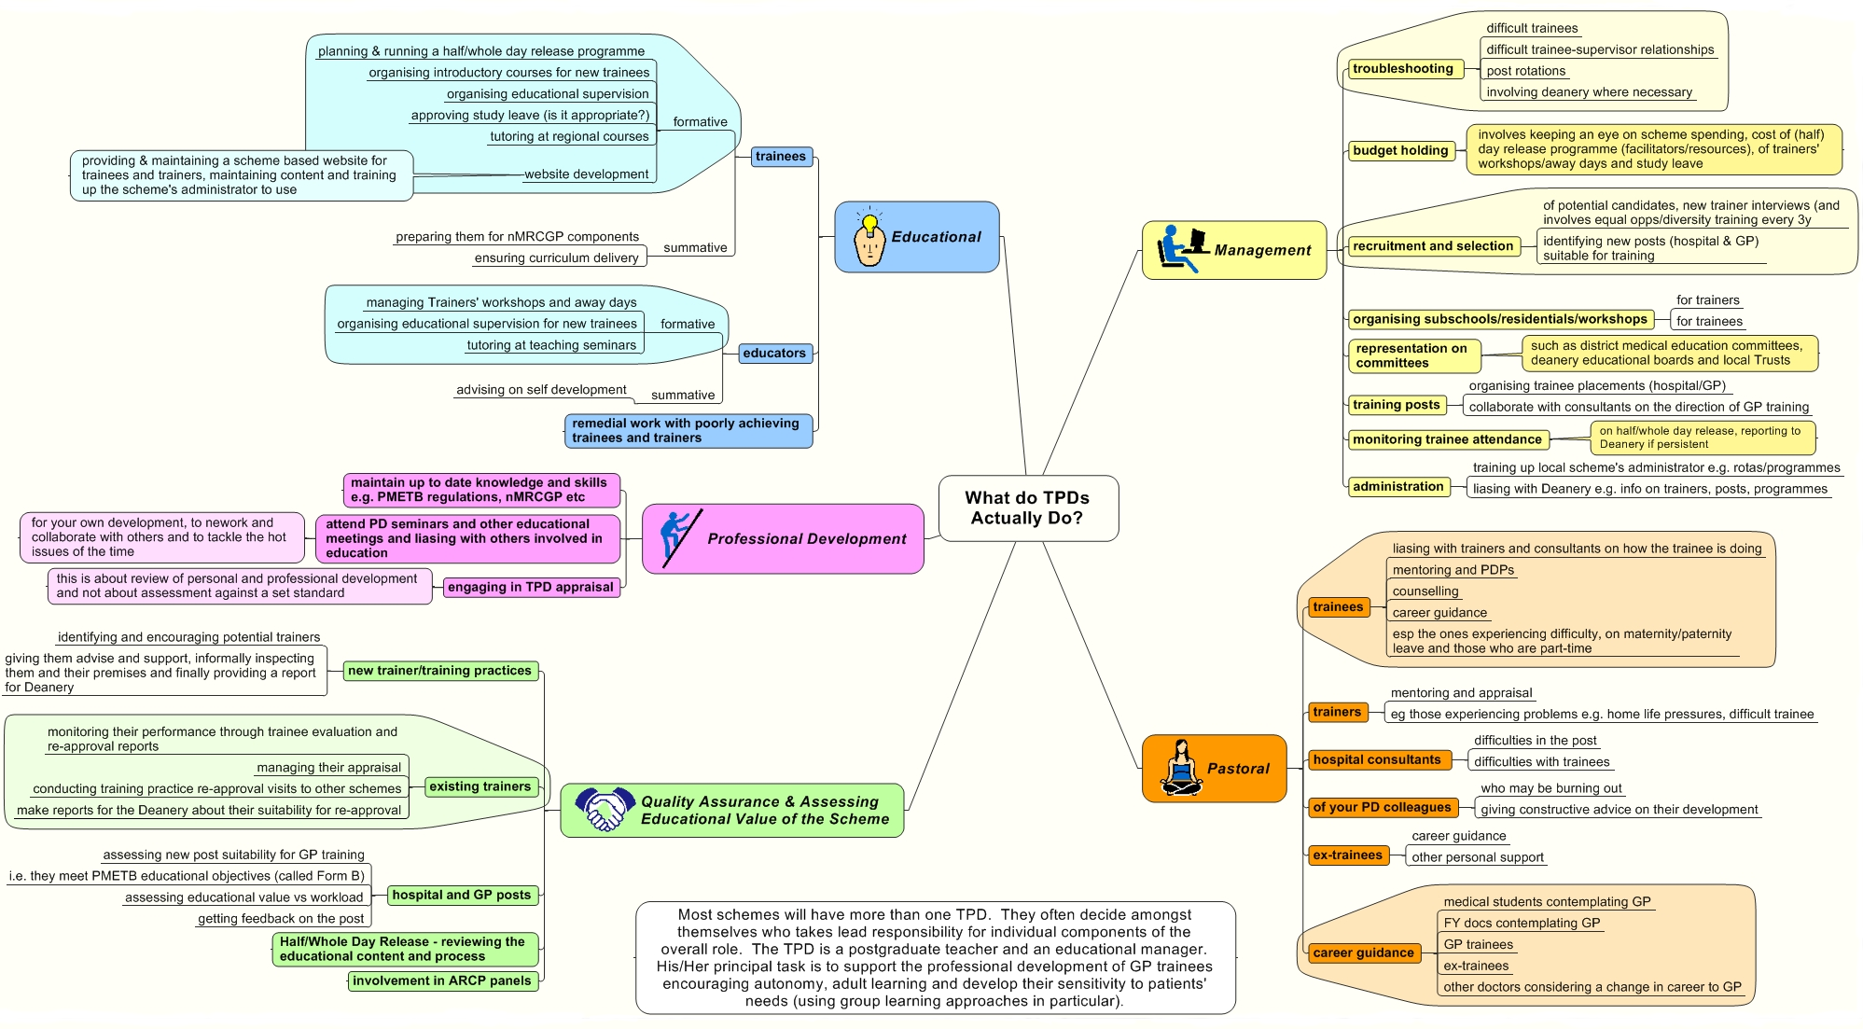

What TPDs Actually Do
A TPD is a facilitator of GP education after the foundation years. He is usually skilled in working in small groups: his job description comes from his deanery. Each deanery may have a slightly different job description, based on a national template.

What the mind map above fails to convey is the satisfaction that can be obtained when things go well and the freedom that exists for innovative work together with the positive encouragement that such work receives from the Deanery. But above all, it doesn't convey the sense of shared achievement that is realised when GP trainees are seen to develop the knowledge, skills and attitudes, necessary for General Practice.

What Knowledge, Skills and Attitudes Are Required?
TPDs acquire these during the job. The most important section to think about at the start of the job is attitudes.
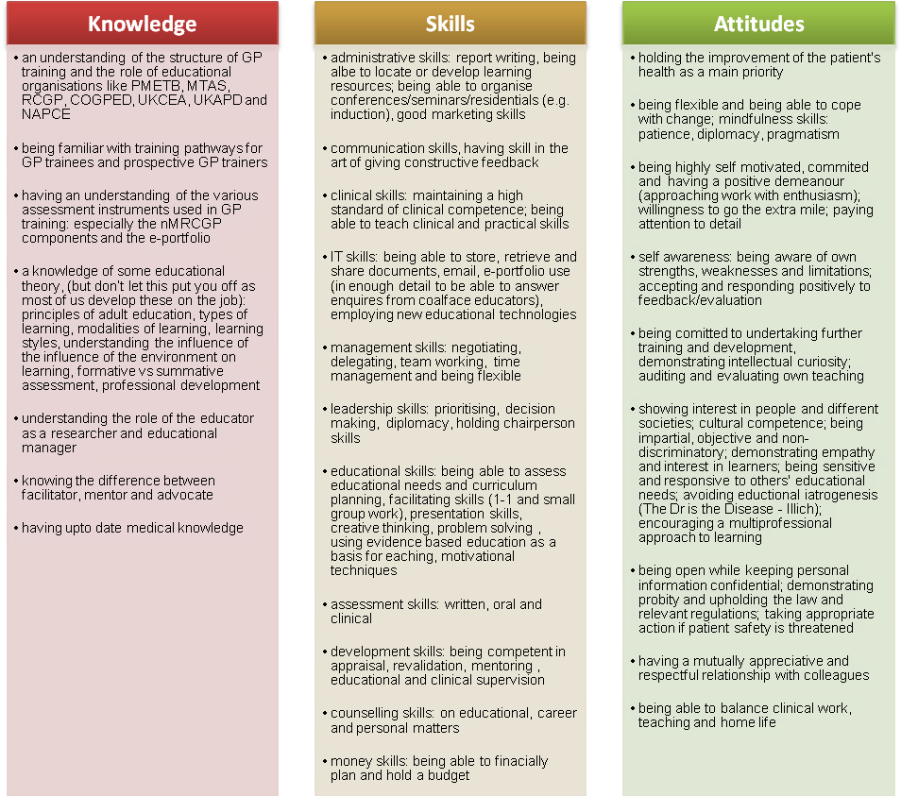

Quick Question-Answer Round

Do I have to be a trainer for x number of years before I can become a programme director?
The answer is no. There are many programme directors who are salaried GPs or locums. You don’t have to be a trainer or a doctor for that matter. Some GPs find this difficult to understand (and accept) but if you think about it, it is not illogical. The programme director has to have an understanding and zest for education. They need to know how that education ‘works’, not necessarily do it. So, as long as programme directors have a good understanding of the requirements for GP training and how it is and could be delivered, then they are usually suitable. Most GPs just out of vocational training are therefore suitable. Seriously, if you are a newly qualified GP, think about applying: you might feel you don’t have much to offer but you do. Whilst you may be working with other TPDs who are well established (and thus provide you with mentorship), you’re in the unique position of being the only one who understands it from the trainee’s perspective. So, go and ring your Deanery and find out if there are any jobs going.

Arghh....I don’t have a degree in Medical Education.
Don’t worry! The minimum requirement is that you have MRCGP. Many but not all PDs have a higher qualification and some deaneries are now asking prospective educators to do a Masters of Medical Education or an equivalent such as the Masters in Medical Ethics or a Masters in Primary Care. Despite this academic language, the most important qualification for anyone involved in medical education is enthusiasm.

Can non-doctors apply to become programme directors?
You bet they can and it is not uncommon to have educationalists who are not doctors. Their contribution has been just as valuable as those of the doctors, and they add an educational dimension and experience which is lacking in those of us who have followed the traditional narrow course into our jobs as programme directors.

What makes a good HDR programme?
The current approach on Half Day Release (HDR) and Day Release (DR) programmes in VTS models the heuristic approach required for modern General Practice. TPDs are enthusiastic GPs modelling good General Practice within an environment that requires and models effective team working and educational principles. Within Balint groups on VTS we model reflective practice that deals with many aspects of the new curriculum which are often difficult to reach in other ways. The promotion of reflective practice (Schon, 1983) alongside the development of positive attitudes to the doctor- patient relationship based on a deeper understanding of the doctor- patient relationship (Balint, 1957), is a unique and integral experience of VTS.

“Setting an example is not the main means of influencing another, it is the only means.” A. Einstein

Due to the nature of small group work, such as occurs in Balint Groups and in Problem-Based Learning (PBL), many aspects of the complexity of General Practice are addressed. Group work in particular has been shown to help address many aspects of the curriculum that are often elusive in other activities, in particular attitudes and values. PBL work in groups is very similar to VTS groups, and promotes deep learning, effective teamwork and personal/professional development of learners (Norman and Schmidt, 1992 and Cawley, 1989).

Should half or whole day release be replaced by solid blocks of protected teaching time?
Recently some schemes have altered from a weekly educational programme like half day release to teaching into solid blocks of protected time (for example, as separate weeks in different parts of the year). This arrangement is not necessarily as popular with trainees as they are with TPDs, because trainees feel that they lose the peer support they gain from weekly teaching. It really depends on what fits in with your local arrangement and what satisfies most of the stakeholders.

How do you manage to map your scheme to the delivery of the GP curriculum?
The six domains (Person-centredness, Primary Care Management, Problem Solving, Comprehensive, Community-based and Holistic practice) and three essential features (Context, Scientific Basis and Attitude) are delivered within VTS in an integrated fashion. The domains and features can be incorporated into VTS in a way that mirrors the new curriculum both in content and process.

Three domains (Person-centredness, Comprehensive and Holistic approaches) are incorporated within an educational approach which values learner- centredness.

The other three domains of Problem Solving, Primary Care Management and a Community Orientation form the remainder of an educational approach which has kept GP Training at the forefront of medical education in the UK.

The three essential features of Attitude, a Scientific Basis and the Context of learning provide the environmental setting and climate for an effective VTS. Trainees are learning about General Practice for General Practice with other practitioners in the field.

What’s the TPD-trainee relationship like compared to the trainer-trainee one?
There is a strong pastoral element to the PD-trainee relationship, but usually not as strong as that with the Trainer. But that’s not to say a TPD may not have close knowledge of most trainees on his scheme, particularly those in their final year, who are close to becoming GPs (though this can depend on the size of the scheme and the TPD’s role). Besides, some trainees feel they would rather approach their TPD rather than the trainer (usually for issues concerning their practice placement). How close that relationship is depends on a) how approachable you are b) the personality of the trainee and c) the size of your scheme (much easier to get to know trainees on a 1-1 level in a small scheme).

How often do the trainers’ workshops run and what’s their point?
These may meet monthly, quarterly or bi-annually depending on local arrangements. The object of the trainers’ workshop is to foster best practice. Some of the things that happen in workshops include:

- For TPDs to disseminate literature and material from the deanery to trainers
- For stakeholders to express their views - educational supervisors, the trainers, and the TPDs
- Provide some educational content, for example to discuss new techniques and advances in education
- To plan the appropriate distribution of the trainees
- To discuss trainees experiencing difficulty and facilitate a remedial package
- To discuss any ‘business’ in relation to GP training
- One of the most invaluable roles the trainers’ workshop provides is peer support for trainers and thus their personal development.
- Quality assurance of approaches to the educational tools like COT and CbD or of how to complete an Educational supervision report.

Some have trainee representatives and some may choose to not to have a TPD.

I am a currently a GP partner. If I become a programme director, should the remuneration for the job be shared with the practice or should I keep it all separate?
Most TPDs are General Practitioners, and they can either be full-time or part-time, partners or salaried doctors. If they are GP partner, a decision has to be made within their practice as to whether the remuneration for their job is shared (horizontal equity) or is kept as individuals (vertical equity).

The method of equity is usually determined the dynamics within the practice and its flexibility. There are pros and cons to each arm.

As a contact with the practice: that is, the TPD pay goes into the practice and you therefore retain your partnership profit sharing ratio. This is good if you are a high earning practice (the sessional rate for a GP in a high earning practice is much better than that of a TPD; a TPD session is currently around £8000 per year).

Pros:
- You retain your partnership profit share and thus better pay (usually)
- You might find it easier to get release from the practice to go on certain TPD related educational events (arguing that these are necessary for the role which the practice is being paid for). Care: they might then say “it’s not worth it”)
Cons:
- The practice can say at any point “we don’t want you to do this anymore”
- The partners and others can resent you for being away a lot. Why should the others stay on the ‘shop floor’ whilst you wander off? (However, a perception vs. reality check needed!). This argument falls flat on its feet if all the other partners are also involved in “special interests”.

Where you do it as a separate job: that is, the TPD pay goes separately to you and has nothing to do with the practice. Therefore, you can’t be a full time partner: most of us do 2-3 PD sessions meaning that one would need to be a 7/9ths partner or less.

Pros:
- Money matters are a lot more simple
- The practice cannot really ask you not to do it
- You feel far less guilty (I think)
- NHS pension contributions continue (through the University who employs you)
Cons:
- You have to decide which events to go on as some may eat into your annual leave/social life.

I am a currently a GP partner. If I become a programme director, the practice would like to know what’s in it for them. What do I say?
Some of the points below might appear a bit nebulous and therefore it’s really important to say them with conviction:
- The education-organisation skills that you will pick up can be useful in all kinds of practice events: for example, designing effective in house educational events, chairing practice meetings and the different approaches to solving practice issues just to name a few.
- There will be educational material generated from small group work or visiting other practices as part of re-approval processes that might be helpful with practice systems and protocols, thus avoiding duplication of work or reinventing the wheel. Examples: home visiting guidelines, chaperone policies, simplifying protocols for complex clinical areas like CKD etc.
- You’ll be “in the know” about many things relating to GP developments,, training and education at the strategic level and that will mean the practice will be too (helpful with the practice’s future strategic plan)
- If the practice needs to appoint new doctors, you are in a v good position to head hunt them (a bit of a perverse incentive!)
- the practice’s reputation with people who are interested in education may be enhanced
- the new challenge may refresh you and make you a more positive person around the practice.

How does GP trainee recruitment work these days?
Prospective GPs who are applying for training apply to a single deanery. Applications are received at deanery level which then arranges a fair and equitable system of assessment. Following this assessment, the candidates are ranked, and having indicated their preferences for schemes within the deanery on their application forms, posts are allocated accordingly. PDs are usually involved in the recruitment process.

This system has the great advantage of being overt and fair. However it does have disadvantages. Rural or smaller vocational training schemes, which are often remote from their deanery centres and big cities, may suffer from a lack of interest and applications. This system is also a problem for couples and families, who can be often separated by large distances.

What about the set up in Scotland, Northern Ireland and Wales? Are they similar to the UK?
Except for Scotland, the answer is yes. In Scotland, there are neither TPDs nor course organisers. However, the UKAPD represents anyone who facilitates small group learning in primary care whatever the nomenclature. Come along to one of their meetings and start networking more widely within the UK (www.ukapd.org).

Sounds like you TPDs do a lot of work and I admire your passion and enthusiasm. Seriously, what do you get out of it for YOURSELF?

We can only speak for ourselves but we are sure what we have to say will be the same for others.

- Firstly, teaching is extremely fulfilling. Many GPs who are well established in their everyday work find it valuable to develop a new are of interest and skill. The satisfaction from seeing young new doctors develop because of the way you have trained them is immeasurable. Frequent contact with fellow TPDs, trainers, practice manager is stimulating and keeps you own your toes. Your work will make a positive difference to all these different stakeholders and many will even say so directly.
- And this feeling of contribution – that you are putting something back into the profession by passing on skills you have developed on to the next generation. Contribution invariably leads to more personal satisfaction and self worth.
- Some of this involves some great challenges, which means the job is very absorbing and never becomes stale and boring.
- And there are so many opportunities like developing new educational events in innovative ways. These help build your presentation, chairing, feedback and consulting skills further.
- But not only that, you learn and develop a lot yourself. Working on these challenges invariably brings you into contact with some magnificent people who you learn from further. There are so many transferable educational and managerial skills you pick up which you can take back to the practice or your home life.

In essence, I think it makes me a stronger, wiser and generally more rounded person. Now that can’t be bad...

Getting support and inspiration
There will normally be some support from fellow PDs in your deanery, and most deaneries will have some variety of educator time out and induction programmes. The level and type of contact between PDs and the more senior educators at Deanery level can be variable, in some places a happy family in others less functional perhaps. Wherever you are you can get support and ideas from the national organisation for course organisers/ programme directors/ group facilitators; the UKAPD.

UK Association of Programme Directors
The UKAPD is the main organisation you should strongly consider joining:
- The annual membership fee is pretty low and some deaneries will reimburse this.
- The annual membership includes a subscription to the highly informative ‘Education in Primary Care’ journal (often referred to as the ‘Green Journal’); a separate subscription to this costs more than their annual membership!
- They run some educational workshops for new and established TPDs
- Their website provides some useful online resources and a forum (where you can chat to other colleagues)
- And finally, their exceptional annual conference is place where you can meet new people, share exciting new ways of doing things, help resolve problems, have some time out, recharge your batteries, find some personal support and have some fun; often held in wonderful locations rotating throughout the country.

Embracing Challenges and Changes
The UKAPD particularly welcomes the opportunity to build on current educational practice in the delivery of Vocational Training Schemes (VTS) in the UK whilst embracing the challenges of the future.

Principles of adult education are central to delivery of the new curriculum (Brookfield, 1990) and the UKAPD has core educational values which support:
- the creation of a climate conducive to learning,
- utilising learners’ prior knowledge and experience,
- acknowledge the requirement for VTS to support learning that has a practical application for trainees, and
- supports the development of self-directed life-long learners by engaging trainees in all aspects of the learning activities.

As Rogers wrote; “The purpose of adult education is to help them to learn, not to teach them all they know and thus stop them from carrying on learning” (Rogers, 1988)

Helping Construct Meaning and Making Sense of Learning
The UKAPD and its members are committed to providing educational programmes which are constructively aligned with the new curriculum for GP. There is recognition of the continuing need to provide and support a wide range of teaching and learning activities for GP trainees. By aligning these educational activities we believe the opportunities are maximised for trainees to construct meaning and make sense of their learning on VTS. (Biggs, 2003)

VTS reaches the part of education that no other bits reach. UKAPD helps make it happen.
If you want to know more, check out their website: www.ukapd.org . You can find a copy of their full affirmation statement at http://www.ukapd.org/news/statement.htm .

Reflecting as an Educator

I can easily describe what I teach and why, but I have no idea how to describe my philosophy as an educator. I have my appraisal coming up soon, so how can I think about this topic in an organised way?
Expect your educational philosophy to evolve with your experience as an educator. Don't lose heart if your first effort is a struggle - you will grow as you flex your intellectual muscles and sharpen your perception of what "really" matters to you as a teacher!
A strong educational philosophy statement describes application of a structured and thoughtful approach, and grounding in educational experience. Your teaching beliefs should evolve from your understanding of theory coupled with your reflection on your teaching experiences. Your appraiser might look at your educational philosophy and then look for examples throughout your portfolio that demonstrate a commitment to these principles.

Questions to reflect upon before writing about your educational philosophy (for example, prior to your annual appraisal):
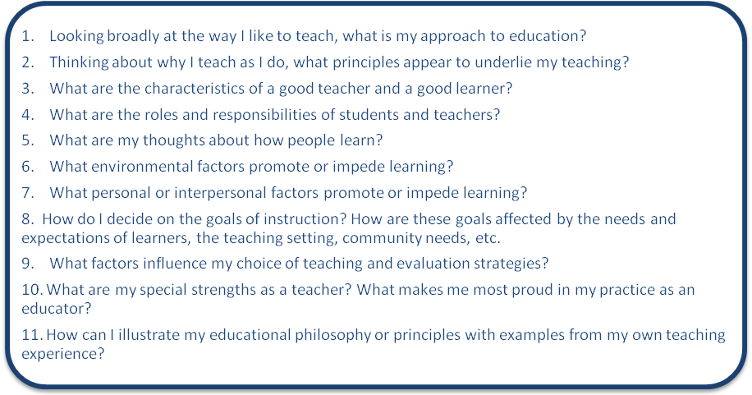

From: The Educator Portfolio: A Tool for Career Development by Constance Baldwin, Maryellen Gusic and Latha Chandran

http://www.aamc.org/members/facultydev/facultyvitae/winter08/leadership.htm

Appraisal is deemed to signify the formal (yet confidential) process of identifying achievements and needs for personal and professional development of employees. The agreed outcome of appraisal may be used for future reflection and consideration of motivation and ability to achieve personal objectives.

Closing Statement
It is great fun being a TPD:
Being a programme director can be a very enjoyable job. Most TPDs do the job because they love it, and money is not a motivator. It widens your circle of contacts and interest. It keeps a doctor in touch with changing educational ideas and standards, and is a motivator. For those of us who've been TPDs for many years we take great pride in watching the achievements and development of our trainees.
We believe that we are developing adult learners with those skills which allow them to enjoy a lifetime of learning. In the final analysis, and speaking as facilitators, the main irony is that a TPD knows when he is being successful by how often he feels redundant! The more redundant you feel, the more likely your trainees have become self-directed learners.

It would be useful to have more hard “evidence” of our worth, but the reader might reflect that of all the parts of the NHS that other world governments would like to emulate, the UK Primary Care service is what they’re most envious of. We remain convinced that we have been doing a public “good” in being TPDs, and the evidence that this is true is in the young, and not so young, doctors we see in the National Health Service.

General practice is one of the most challenging jobs, and the opportunity to train future General practitioners is a great privilege.

One Stop Resource Shop

The GP Curriculum
The knowledge, skills and attitudes that a GP training programme is expected to provide:
http://www.gpcurriculum.co.uk/
http://www.rcgp-curriculum.org.uk/

The Gold Guide
This document tells you about the “rules” of postgraduate training for all doctors. It’s available from the MMC website (if the link below fails for any reason, just type “gold guide” into the search box).
http://www.mmc.nhs.uk/default.aspx?page=457

Bradford VTS Website
nMRCGP; online resources for trainees and trainers
www.bradfordvts.co.uk

GP-training.net
nMRCGP; online resources for trainees and trainers
www.gp-training.net

UKAPD
Resources section; donated from programme directors all over the UK
www.ukapd.org

